March 2017
It has now been six years since the March 2011 tsunami off Japan damaged the Fukushima Dai-ichi Nuclear Power Plant and resulted in unprecedented releases of cesium-134, cesium-137, and many other gaseous and volatile radioactive elements to the Pacific Ocean. From the early days of the disaster, we have tracked the spread of these radioactive contaminants throughout the ocean and east towards North America. Since 2013, with the continuous support and sampling by citizen scientists with Our Radioactive Ocean (ORO), we have monitored the waters off the West and, in 2015 and 2016, samples collected by ORO volunteers showed the arrival and spread of contamination directly linked to Fukushima on this side of the Pacific.
Our work does not end with that discovery, however. TEPCO, the utility company that operated the plant and continues to oversee the cleanup effort, recently found the highest radiation levels to date (530 Sieverts) in Reactor 2, the one most heavily damaged by an explosion after the tsunami. It is important to note that these measurements were the first to be made inside the primary containment vessel of Reactor 2, where radiation levels were expected to be high as a result of nuclear fuel being stored there.
Although the long-term storage and removal of this material is of obvious concern, there is currently no evidence that this radiation is leaking from Reactor 2 into the surrounding air or water, but we continue to watch for signs that this might occur. For example, on our most recent cruise to Japan in November 2016 we found elevated cesium, but at levels no higher than what we saw in recent years. This means that the tons of water escaping the site remain contaminated, but at levels thousands of times lower than what we saw at the beginning of the accident. Given that the contamination has not lessened and still exists on-site, monitoring and remediation efforts need to continue throughout the decades-long decommissioning process to ensure that further releases do not occur.
Until recently we have been using cesium-134 as a “fingerprint” of Fukushima in the Pacific. Because this isotope has only a two-year half-life and because we know of no other significant sources of it to the ocean, any amount we find must have come from Fukushima. After six years—three half-lives of the isotope—the amount of cesium-134 in the ocean has decayed to approximately 12% of the original amount released. This makes what was already in low concentration even more difficult to detect. Instead, we are now looking at the trend of increasing cesium-137 found along the West Coast as a more reliable signal indicating the presence of contamination from Fukushima.
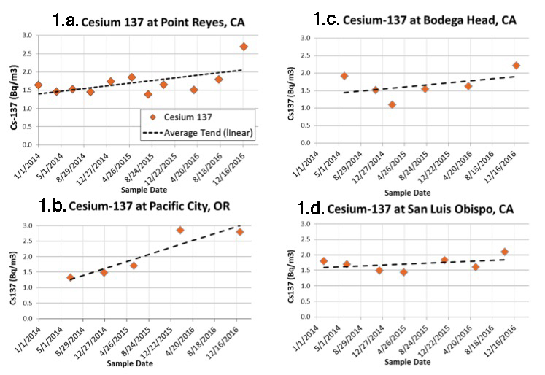
Figure 1. Cesium-137 vs. sampling time at 4 U.S. coastal locations. Dashed line is the linear trend showing small increases due to arrival of cesium from Fukushima. These levels are thousands of times lower than U.S, drinking water limits and lower than equivalent values in the ocean in the 1950s and 60s caused by nuclear weapons testing in the Pacific.
Our highest levels to date of cesium in coastal waters have been found near Pacific City, Oregon, with total cesium-137 levels between 2.8 and 3.2 Becquerels per cubic meter (Bq/m3) (Fig. 1a). Pre-Fukushima levels of cesium-137 along the coast were generally below 2 Bq/m3, mostly the result of nuclear weapons testing in the Pacific.
Continuous monitoring at several sites (Point Reyes, Figure 1a; Pacific City, 1b; Bodega Head, 1c; and San Luis Obispo, 1d) has allowed us to identify a clear trend in the increase of cesium-137 over the past three years that also appears when we plot results from all coastal sampling sites. However, we do not have complete time series at many other sites, so we have compiled a map to indicate where we have seen the telltale sign of cesium-134 from Fukushima in prior sampling, both along the coast and further offshore (Figure 2).
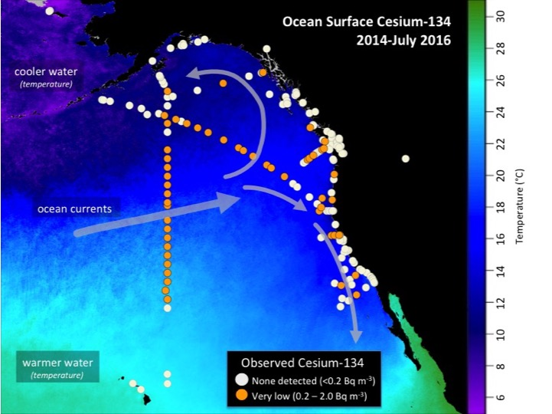
Figure 2. Map showing locations of samples with measurable cesium-134 (orange circles) carried by ocean currents from Fukushima. All samples have detectable cesium-137 as a result of atmospheric nuclear weapons testing in the 1950s and 60s. All data available at OurRadioactiveOcean.org (updated July 2016).
It is important to note that the levels we see are still extremely low, more than 500 times below both the U.S. drinking water standard and any level thought to pose a harm to marine life or to humans as a result of swimming or other contact with sea water. We don’t expect these levels to get much higher, but until they start to decrease, we will not know what peak levels will be along West Coast beaches.
Finally, we published an open-access review of Fukushima and its impact on the ocean (available here) in January 2017 that includes data from our sampling efforts to look at the spread of cesium across the Pacific to the West Coast. It also covers the changing levels of Fukushima contaminants in marine biota as well as the potential health effects and societal impacts of these releases.
As we begin to see higher levels of cesium along the West Coast of North America and concerns continue to arise in the media and elsewhere, it becomes even more vital that we continue our monitoring efforts. We still need to determine the timing and magnitude of peak levels relative to releases from Fukushima, for example. It is also important that we continue provide the public with unbiased information about the impact of Fukushima on the ocean. We want to thank the hundreds of donors and citizen scientists who have made this possible and hope to continue our efforts into 2018 and beyond

